

HR MANAGEMENT SYSTEM

submitted in partial fulfillment of the requirement of

BACHELOR

IN

COMPUTER ENGINEERING

BY

Armaan Nakhuda 02

Sushant Navle 05

Samay pandey 09

Peeyush Karnik 57

Supervisor

Vedika Patil



Department Of Computer Engineering

K.C. College of Engineering and Management Studies and Research

Mith Bunder Road, Kopri, thane (E) - 400603

University of Mumbai (AY 2023-24)

CERTIFICATE

This is certify that the mini project entitled “HR MANAGEMENT SYSTEM ’’ is Bonafede work of Armaan Nakhuda (B-02); Sushant Navle (B-05); Samay pandey (B-09); Peeyush Karnik (B-57) submitted to the University of Mumbai in partial fulfillment of the requirement for the award of the degree of “Bachelor of Engineering in Computer Engineering”.

Supervisor

Prof. Vedika Patil

Head of Department Principal

Prof. Mahesh Maurya Dr. Vilas Nitnavare

Mini Project Approval

This mini project entitled HR MANAGEMENT SYSTEM by Armaan Nakhuda (B-02); Sushant Navle (B-05); Samay pandey (B-09); Peeyush Karnik (B-57)is approved for the degree of Bachelor of engineering in Computer Engineering.

Examiners

1..............................................................................

(Internal Examiner Name & sign)

2.....................................................................

(External Examiner name & sign)

Date: -

Place: -

Contents

Abstract

Acknowledgement

List of abbreviations

List of figures

1. Introduction

1.1 Introduction

1.2 Motivation

1.3 Problem Statement & Objectives

2 . mini project contribution

3 . Proposed System

3.1 Introduction

3.2 Architecture or Framework

3.3 Details of hardware and software

3.4 Experiment and Results

3.5 Conclusion and future work

4 . References

1

List Of Figure

|  |  |  |
| --- | --- | --- |
| Figure  no. | Figure Name | Page no. |
| 1. | Loading Screen | 14 |
| 2. | Game Option Screen | 15 |
| 3. | 1 Player Game | 16 |
| 4. | Winning animation in 1 Player Mode | 17/18 |
| 5. | 2 Player Game | 19 |
| 6. | Winning Animation in 2 Player Mode | 20/21 |
| 7. | Pause menu and Credits Dialogue | 22 |

2

Abstract

TICTACTOE Game, a classic two-player game, has captivated the minds of young and old players for generations. This abstract introduces a modern and innovative perspective on the game by integrating artificial intelligence (AI) algorithms to enhance gameplay and strategy.

This study focuses on the development of a HR MANAGEMENT SYSTEM that incorporates AI-based decision-making, providing players with challenging opponents that adapt and evolve their strategies over time. The implementation of the Minimax algorithm, coupled with the Alpha-Beta Pruning technique, ensures an optimal and efficient gameplay experience. Additionally, a user-friendly graphical interface is designed to facilitate an enjoyable and intuitive gaming experience.

Through this approach, players can engage in HR MANAGEMENT SYSTEM matches with both human and AI opponents, offering a stimulating and dynamic gaming environment. The game allows users to select from different difficulty levels, where the AI's decision-making ability ranges from novice to expert, making it suitable for players of all skill levels.

Furthermore, this application explores the significance of AI in enhancing traditional board games like TICTACTOE Game, providing insights into how technology can revitalize and redefine classic pastimes. By merging strategy and AI, this project aims to reignite interest in this timeless game, catering to the preferences of both casual players and enthusiasts alike.

Overall, this research contributes to the field of gaming by showcasing the potential of AI integration in transforming the gaming experience, offering a fresh and challenging take on the beloved TICTACTOE Game.

3

Acknowledgement

We would like to express our sincere gratitude to all those who contributed to the development and success of this HR MANAGEMENT SYSTEM project.

First and foremost, we extend our appreciation to our team members for their dedication and hard work in designing, programming, and testing the game. Their collective efforts played a vital role in bringing this project to fruition.

We are also thankful for the guidance and support of our project supervisor Prof. Vedika Patil whose expertise and insights were invaluable throughout the development process. Your mentorship and encouragement significantly enriched our project.

We would like to acknowledge the countless individuals who provided feedback, participated in beta testing, and helped refine the game. Your input was instrumental in enhancing the overall user experience.

Additionally, we are grateful for the open-source software community, whose contributions laid the foundation for many of the tools and libraries used in this project.

Finally, we want to express our heartfelt thanks to our friends and family for their unwavering support and understanding during the project's development period. Your encouragement and patience were essential in helping us overcome challenges and stay motivated.

This project would not have been possible without the collaborative efforts and support of all these individuals and groups. Thank you for being part of this journey.

4

List Of Abbreviation

A list of common abbreviations used in the context of a TICTACTOE Game:

1.AI:-Artificial Intelligence

2.Tie/Draw:-When the game ends in a draw with no winner

3.Restart:- Option to start a new game after finishing one

4.Undo:- Option to revert the last move made in the game

5.UI:- User Interface

6.O:-Player using circles or "O" in the game

7.X:-Player using crosses or "X" in the game

These abbreviations are commonly used when discussing the technical aspects and gameplay elements of a HR MANAGEMENT SYSTEM

5

INTRODUCTION

1.1 Introduction

TICTACTOE Game, often referred to as "Noughts and Crosses," is a timeless classic among board games. Its simplicity, yet potential for strategic depth, has made it a favorite pastime for people of all ages around the world. This game, played on a 3x3 grid, requires two players who take turns marking the grid with their respective symbols, typically "X" and "O." The objective is straightforward: be the first to complete a row, column, or diagonal with your symbols.

While HR MANAGEMENT SYSTEM might seem deceptively simple, it offers a captivating blend of tactics, strategy, and suspense. Players must anticipate their opponent's moves while devising their own winning strategies. This intriguing mix of challenge and accessibility has kept HR MANAGEMENT SYSTEM popular for generations.

In this digital age, HR MANAGEMENT SYSTEM has found a new home in the world of computer games. With the advent of technology, it has become easier than ever to enjoy this classic game in various formats, from traditional pen-and-paper to computerized versions with AI opponents.

In this digital incarnation of TICTACTOE Game, we aim to capture the essence of the game's appeal, offering a user-friendly interface and optional AI opponents that adapt to your skill level. Whether you are a seasoned strategist or a casual player looking for a quick game, our digital HR MANAGEMENT SYSTEM promises an engaging and enjoyable experience for players of all backgrounds.

Join us in this journey through the virtual HR MANAGEMENT SYSTEM grid, where simple moves can lead to exhilarating victories and challenging opponents await your every decision. Discover the joy of this ageless game as we bring it to life in a new and exciting form.

6

1.2 Motivation for Creating A HR MANAGEMENT SYSTEM

The creation of a digital HR MANAGEMENT SYSTEM stems from a deep-seated appreciation for the timeless appeal of this classic board game. While HR MANAGEMENT SYSTEM may be one of the simplest games in existence, it has an enduring charm that transcends generations. Several motivating factors drive the development of this digital adaptation:

1.Universal Appeal:-HR MANAGEMENT SYSTEM is a game known to virtually everyone, from children to adults, across cultures and borders. Its simplicity and accessibility make it an ideal choice for people of all ages and backgrounds.

2. AI Innovation:-The integration of artificial intelligence (AI) algorithms presents an exciting opportunity to enhance the game. By offering AI opponents with varying levels of difficulty, we aim to provide players with engaging challenges and opportunities for skill development.

3. Multiplayer Experience:-In today's interconnected world, multiplayer experiences are highly sought after. This digital HR MANAGEMENT SYSTEM allows players to engage with friends, family, or strangers, fostering social connections through friendly competition.

4.Education and Learning:-HR MANAGEMENT SYSTEM can be an excellent tool for educational purposes, helping individuals, especially children, develop critical thinking, spatial reasoning, and pattern recognition skills in a fun and interactive manner.

5. Entertainment and Relaxation:-Games have always been a source of entertainment and relaxation. Our digital HR MANAGEMENT SYSTEM aims to provide an enjoyable and stress-free experience for players seeking a brief escape from their daily routines.

In conclusion, the motivation behind developing this digital HR MANAGEMENT SYSTEM is rooted in a desire to celebrate the enduring charm of a classic, provide a platform for strategic engagement, and offer an inclusive and enjoyable experience for players of all backgrounds. We hope that our adaptation of this timeless game will bring joy, nostalgia, and intellectual stimulation to all who engage with it.

7

1.3 Problem Statements And Objectives

Problem Statements:-

TICTACTOE Game, a simple yet engaging board game, has been enjoyed by players for generations. However, the development of a digital HR MANAGEMENT SYSTEM presents several challenges and problem areas to address

1. User Experience and Accessibility:-Creating an intuitive and user-friendly graphical user interface (GUI) that caters to players of all ages and backgrounds, ensuring accessibility and ease of use on various devices and platforms.
2. Multiplayer Functionality:- Implementing seamless multiplayer features that allow players to enjoy the game with friends or strangers online, considering issues like matchmaking, connectivity, and synchronization.
3. Game Logic and Rules:-Ensuring that the game adheres to the rules of HR MANAGEMENT SYSTEM while preventing illegal moves and accurately detecting wins, losses, and ties, thus maintaining the integrity of the game.
4. Graphics and Animation:-Creating visually appealing graphics and animations to enhance the gaming experience without overwhelming the player or causing performance issues.

8

Objective:-

The development of the HR MANAGEMENT SYSTEM aims to achieve several key objectives, each contributing to the creation of an enjoyable, accessible, and engaging gaming experiences

1. Classic Gameplay:-Provide players with the classic and timeless gameplay of TICTACTOE Game, allowing them to enjoy this beloved board game in a digital format.
2. User-Friendly Interface:-Create an intuitive and user-friendly graphical user interface (GUI) that is easy to navigate, making the game accessible to players of all ages and skill levels.
3. Single and Multiplayer Modes:-Offer both single-player and multiplayer modes, allowing players to challenge computer-controlled opponents with varying levels of difficulty or compete against friends and other players online.

9

2.Mini Project Contribution

There as an equal contribution to this project giving new ideas, proposing the designs, and adding the content to it, gathering information, coding &execution the final result.

10

3.Proposed System

3.1 Introduction

The aim of the project is to understand the development of a Tic-Tac-Toe for Android devices. The project involves creating a mobile app that allows players to engage in the classic two-player Tic-Tac-Toe game as well as play against an AI opponent with varying levels of difficulty.

3.2 Architecture

Creating the architecture for a HR MANAGEMENT SYSTEM involves defining the components, interactions, and flow of the game's software structure. Below is a simplified architectural overview for a basic TICTACTOE Game:

1. HR MANAGEMENT SYSTEM Architecture:-
   1. 1.User Interface (UI) Layer:-
2. Game Board Displays :-the 3x3 grid where players make their moves.
3. Player Indicators:- Shows which player's turn it is (Player X or Player O).
4. Status Messages: Provides information about the game's current state (e.g., win, tie, ongoing).
5. Restart Button:- Allows players to start a new game.
6. Exit/Quit Option:- Provides an option to exit the game.
   1. 2. Game Logic Layer:-
7. Game State Management:-Keeps track of the game's current state, including the grid, player turns, and win conditions.
8. Graphics and Animation Engine:-
9. Rendering Responsible :-for rendering the game elements, including the board, player symbols, and animations.
10. Data Encryption: Ensures secure data transmission in online multiplayer matches.
11. Cross-Platform Compatibility:

Ensures that the game can run on various platforms, such as web browsers, mobile devices, and desktops, while maintaining a consistent user experience. This architecture outlines the major components and interactions within a TICTACTOE Game. Depending on your specific project requirements, you may need to expand or modify this architecture to include additional features or technologies.

11

Flowchart:-

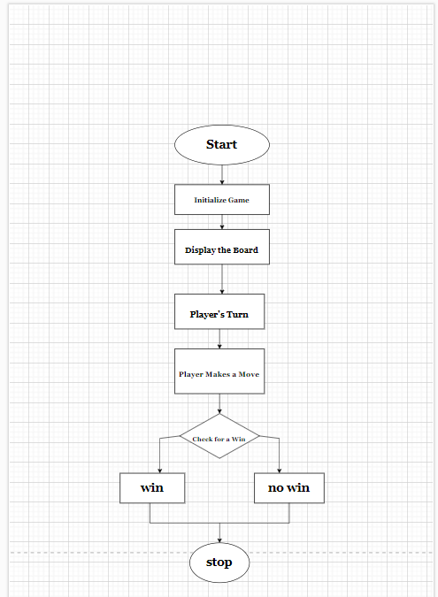

Figure 1

Figure 1 is a flowchart of the basic function of the Game when the user plays it.

1. Initialization: Start the game, set up the game board, and select the starting player (Player 1 or Player 2).
2. Game Loop: Continuously check the game state to see if there's a winner, a tie, or if the game is still ongoing.
3. Player Moves: Display the current game board and prompt the current player to make a move. Validate the move and update the board.
4. Game Conclusion: If there's a win or a draw, end the game and display the result. Ask if players want to start a new game, and if not, end the application.

12

3.3 Hardware And Software Requirements:-

Hardware :-

1. Minimum Requirements:
2. Processor:- Dual core processor @2.4Ghz
3. Ram:- 4GB Ram
4. Storage:- 2GB free space
5. Recommended Requirements:
6. Processor:- Quad core processor @2.8Ghz
7. Ram:- 8GB Ram
8. Storage:- 4GB free space

Software :-

1. Minimum Requirements:
2. API: API Level 30- Android 11
3. Recommended Requirements:
4. API: API Level 34- Android 14

13

3.4 Experimental Result:-

Loading screen:

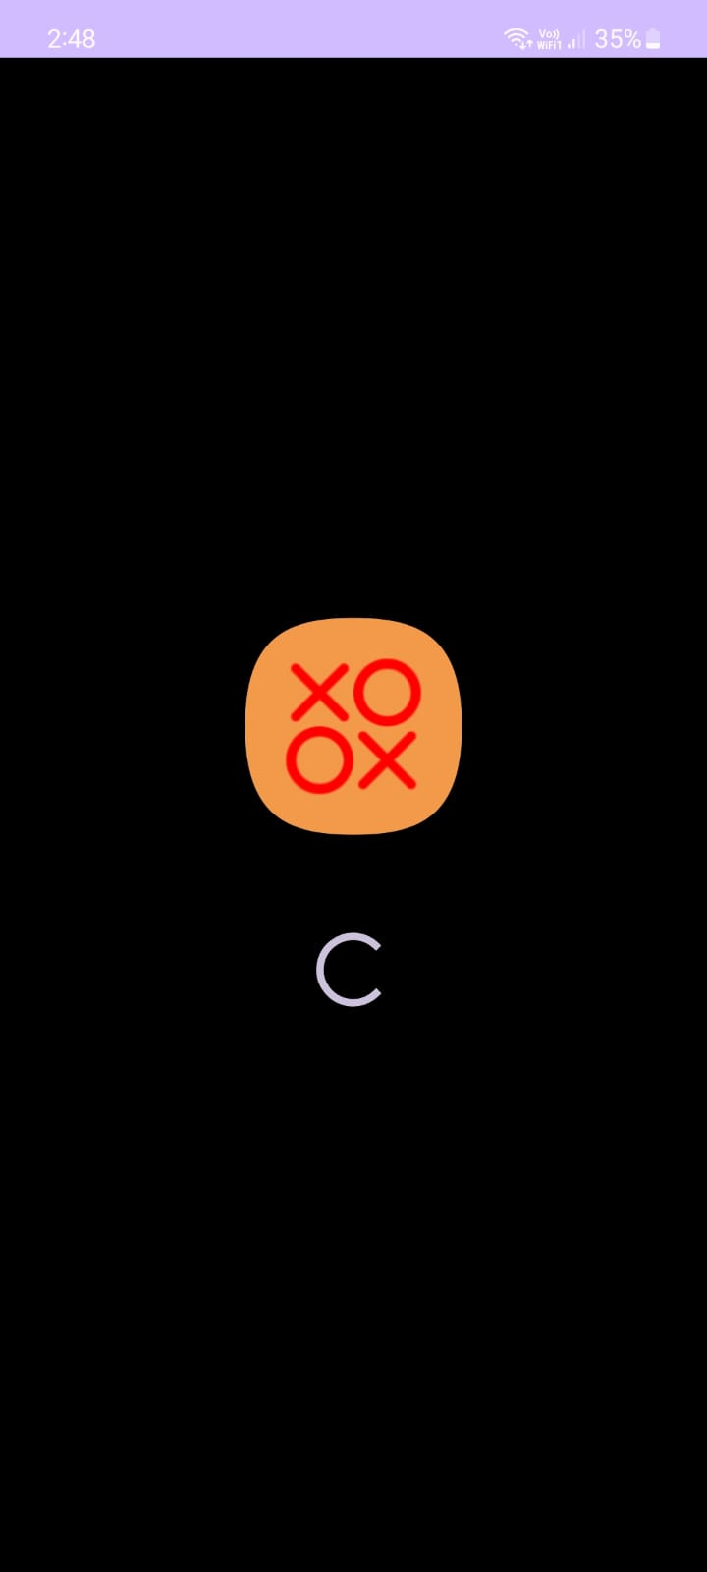

Figure 2

Figure 2- The first Screen shown to the user when the application is opened, it consists of the Application logo and a Spinning progress bar

This screen is shown for a duration of 3 seconds after which the thread has completed and handed over the progress to the Game options Screen.

14

Game Options Screen:

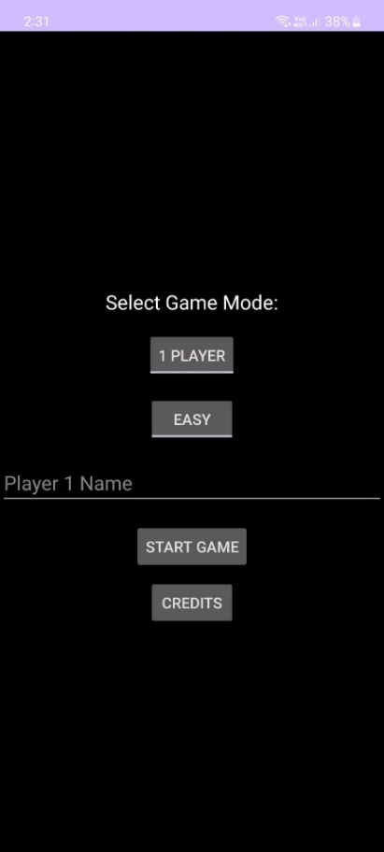 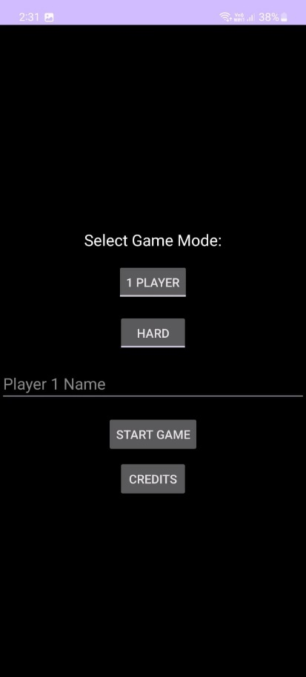 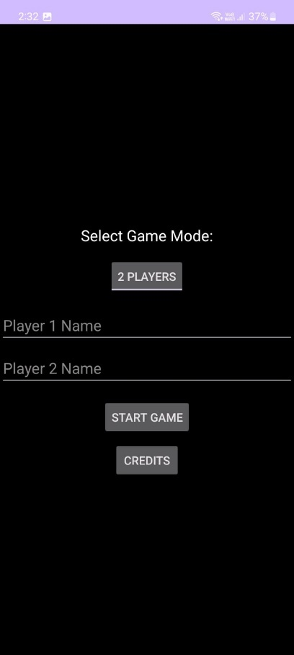

Figure 3 Figure 4 Figure 5

* Figure 3,4,5- This is the Game options screen that comes up after the loading screen has ended.
* Figure 3,4,5- From the top it has a toggle button consisting of 2 options, 1 player mode and 2 player mode.
* Depending on the mode choosen by the user the following options below it change:
* Figure 3,4-For 1 player mode, A second toggle button is visible, which has 2 options for the difficulty of the AI the user will play against, it has easy or hard mode to choose from.
* Following which the text field for the name of player 1 is present.
* Note: Player 2 name text field is hidden as it will default to BOT.
* Figure 5- For 2 player mode, there are only 2 text fields visible for player 1 name and player 2 name.Figure 3,4,5- After these options, there are consistent options of Start Game and the Credits button.

15

1 Player Game:

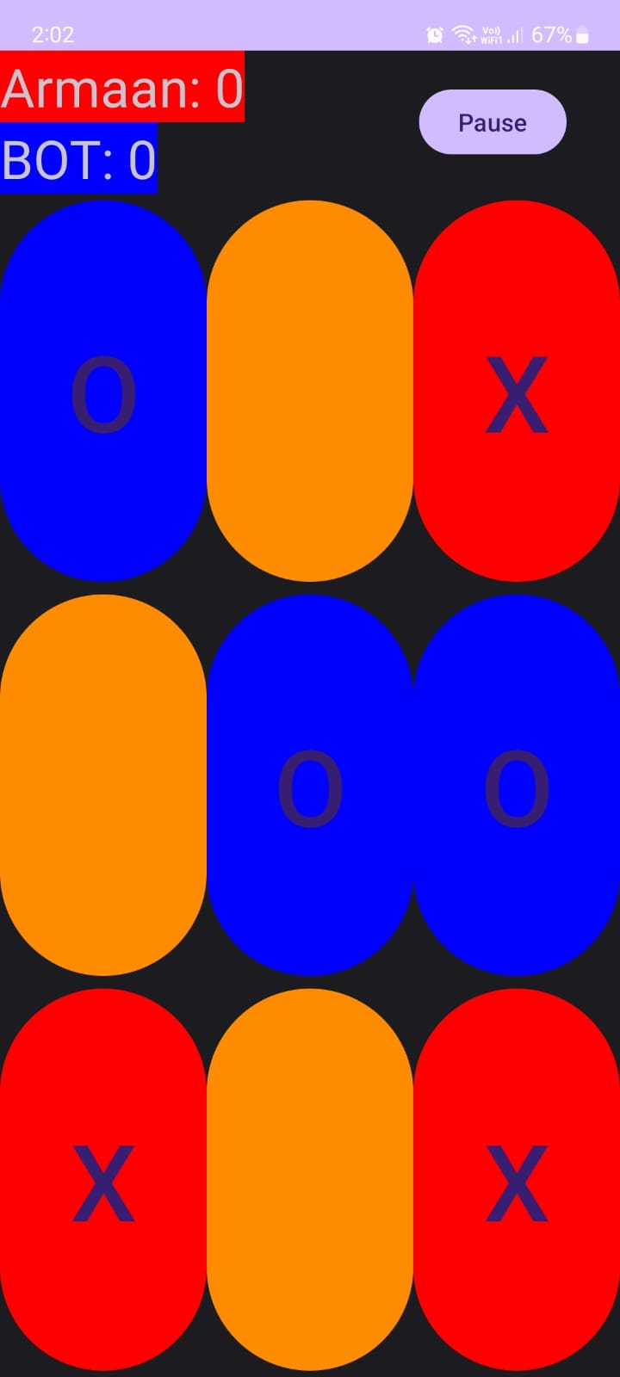

Figure 6

* In this Figure 6, is a screenshot of the session in progress having orange as the default button color, depending on X and O clicking on it, will change to Read or Blue respectively.
* X is player 1 (as shown as the color of the box around the player’s name)
* O is BOT (as shown as the color of the box around the player’s name)

16

Winning Animations in 1 player mode:

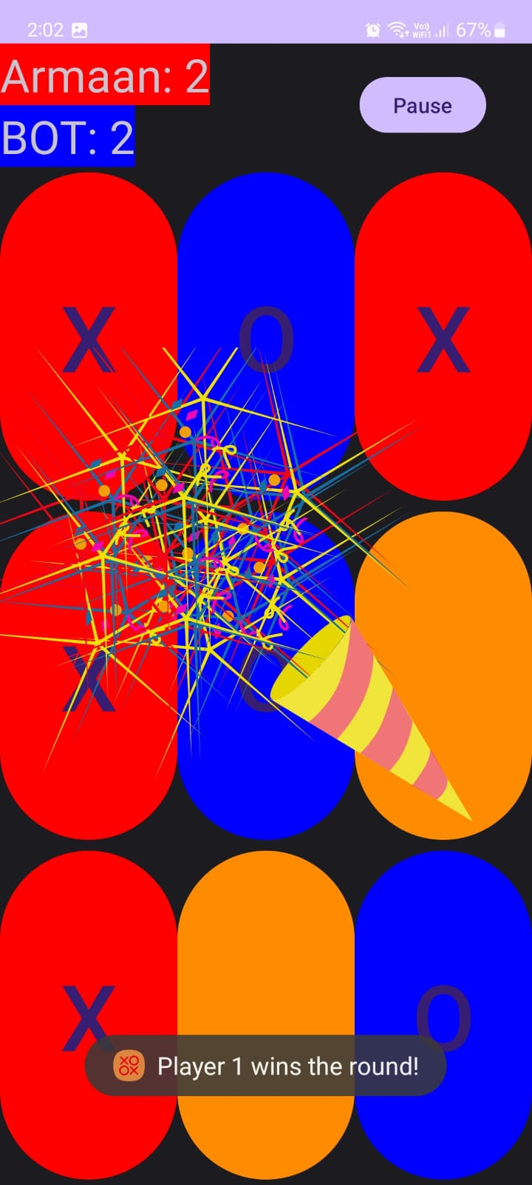 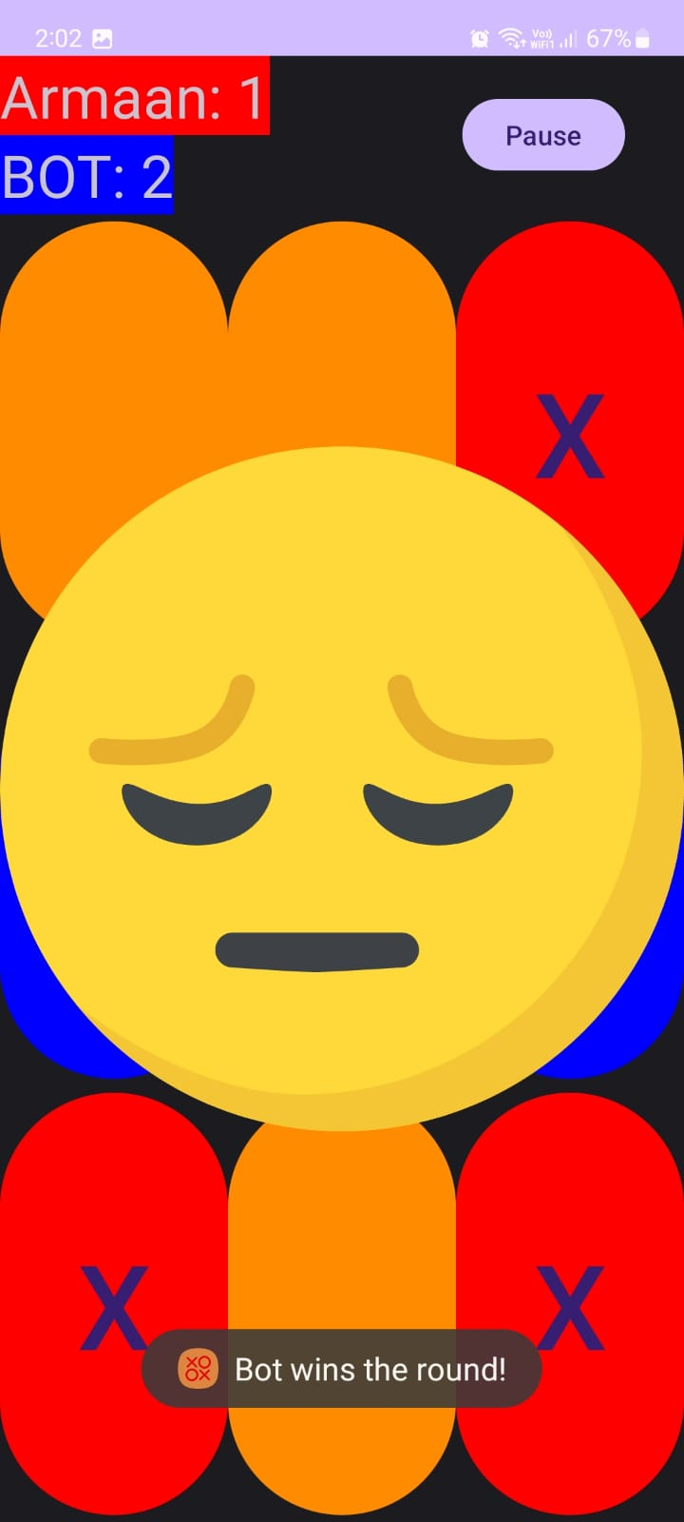

Figure 7 Figure 8

Figure 7- Shows the animation and the toast that is displayed to the user when the user wins the round.

Figure 8- Shows the animation and toast that is displayed to the user when the BOT wins the round.

17

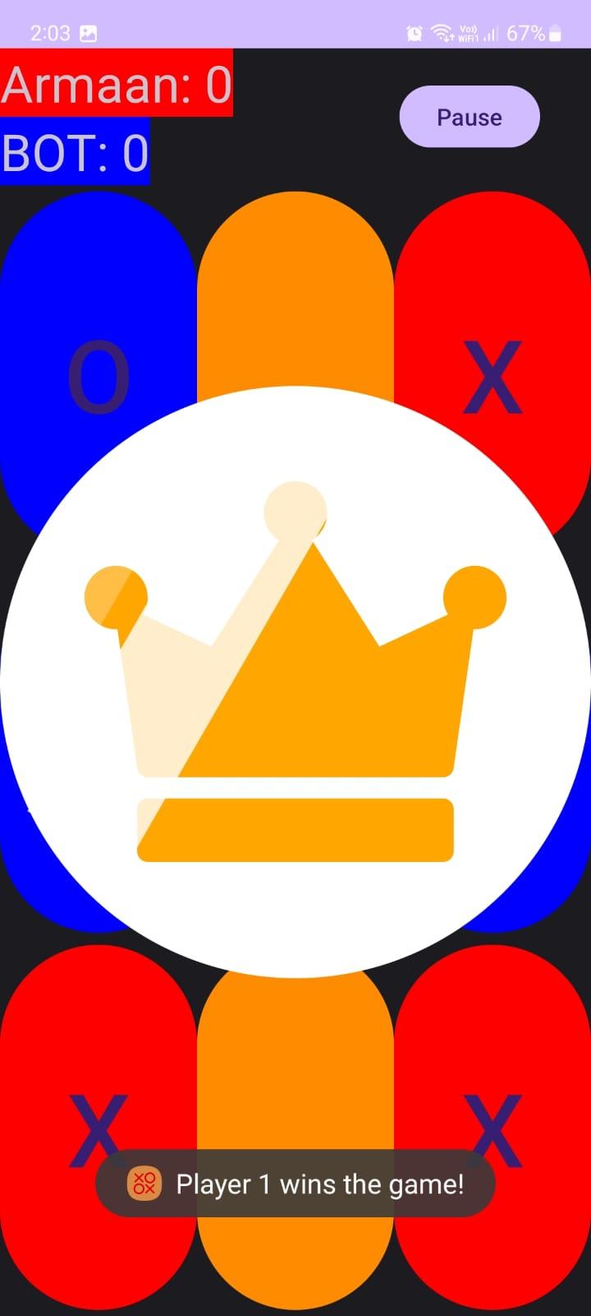 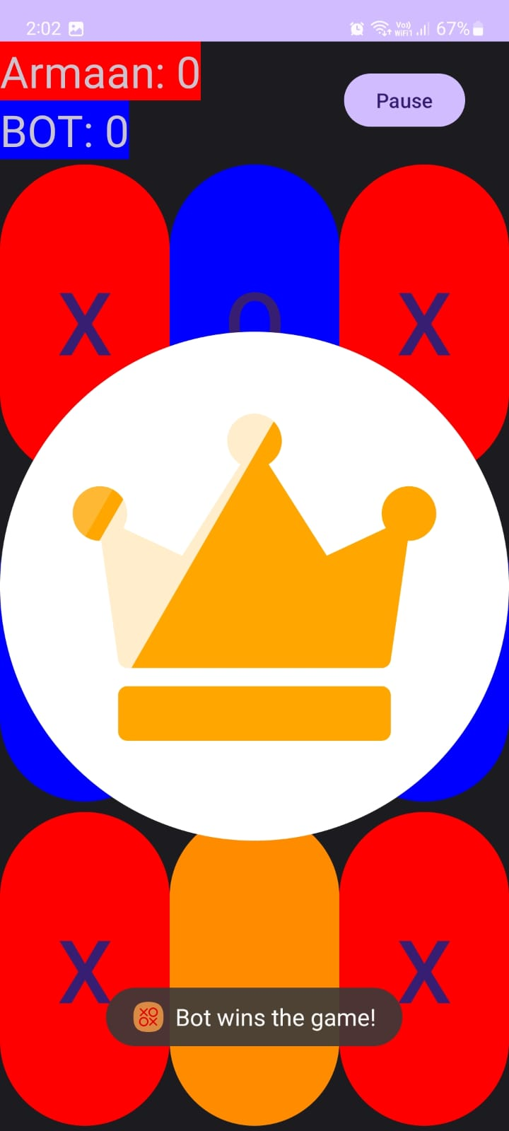

Figure 9 Figure 10

Figure 9- Shows the animation and the toast that is displayed to the user when then user wins the game.

Figure 10- Shows the animation and toast that is displayed to the user when the BOT wins the game.

18

2 Player Game:

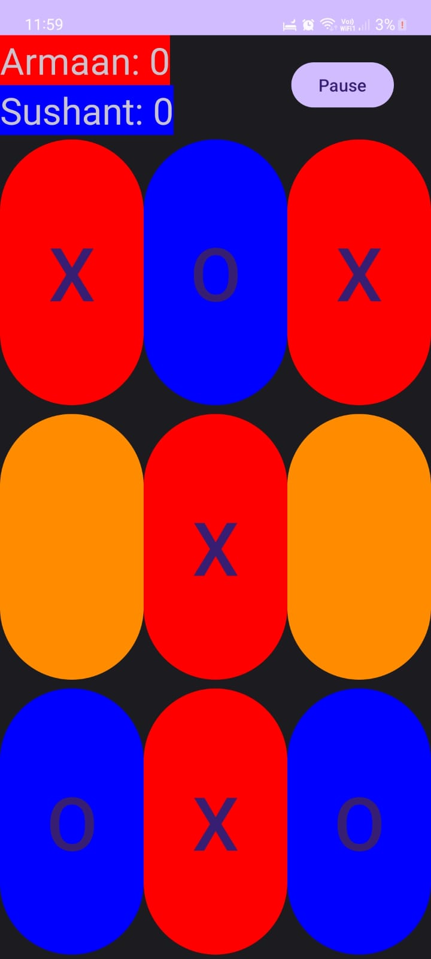

Figure 11

In this Figure 11, is a screenshot of the session in progress having orange as the default button color, depending on X and O clicking on it, will change to Read or Blue respectively.

X is Player 1 (as shown as the color of the box around the player’s name)

O is Player 2 (as shown as the color of the box around the player’s name)

19

Winning Animations in 2 player mode:

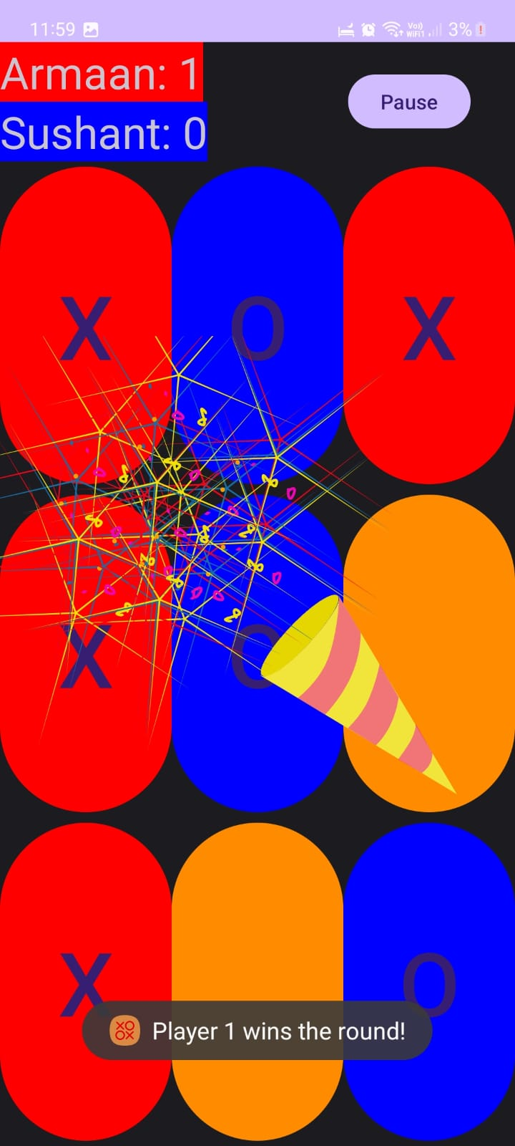 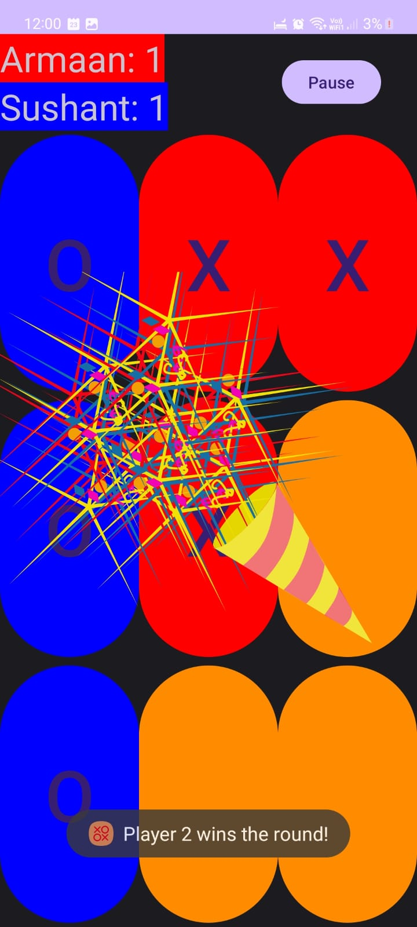

Figure 12 Figure 13

Figure 12- Shows the animation and the toast that is displayed to the user when Player 1 wins the round.

Figure 13- Shows the animation and the toast that is displayed to the user when Player 2 wins the round.

20

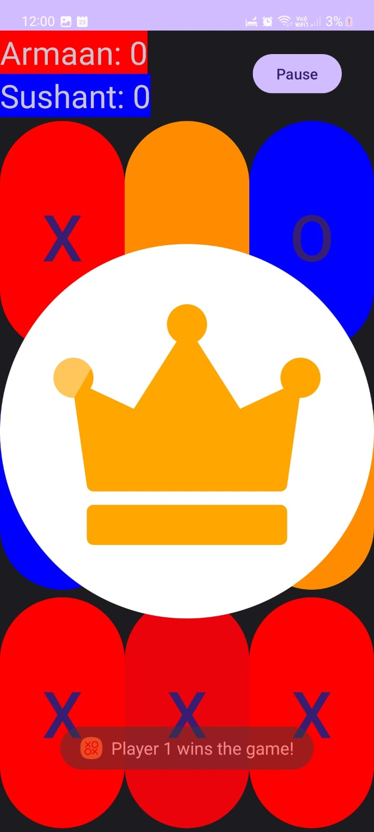 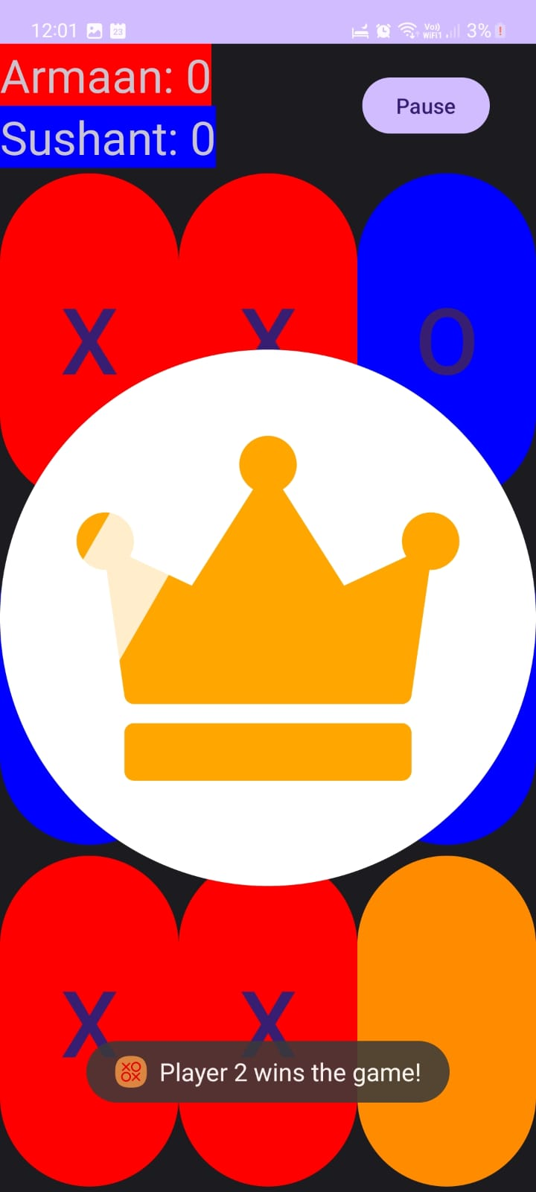

Figure 14 Figure 15

Figure 14- Shows the animation and the toast that is displayed to the user when player 1 wins the game.

Figure 15- Shows the animation and toast that is displayed to the user when player 2 wins the game.

21

Pause Menu and Credits Dialogue:-

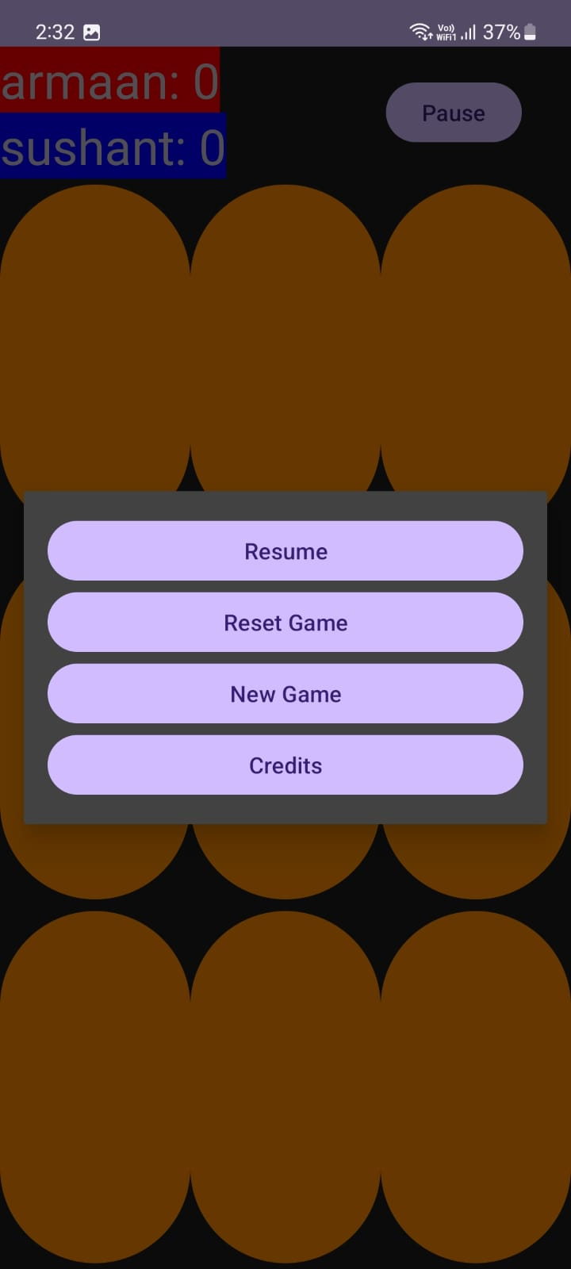 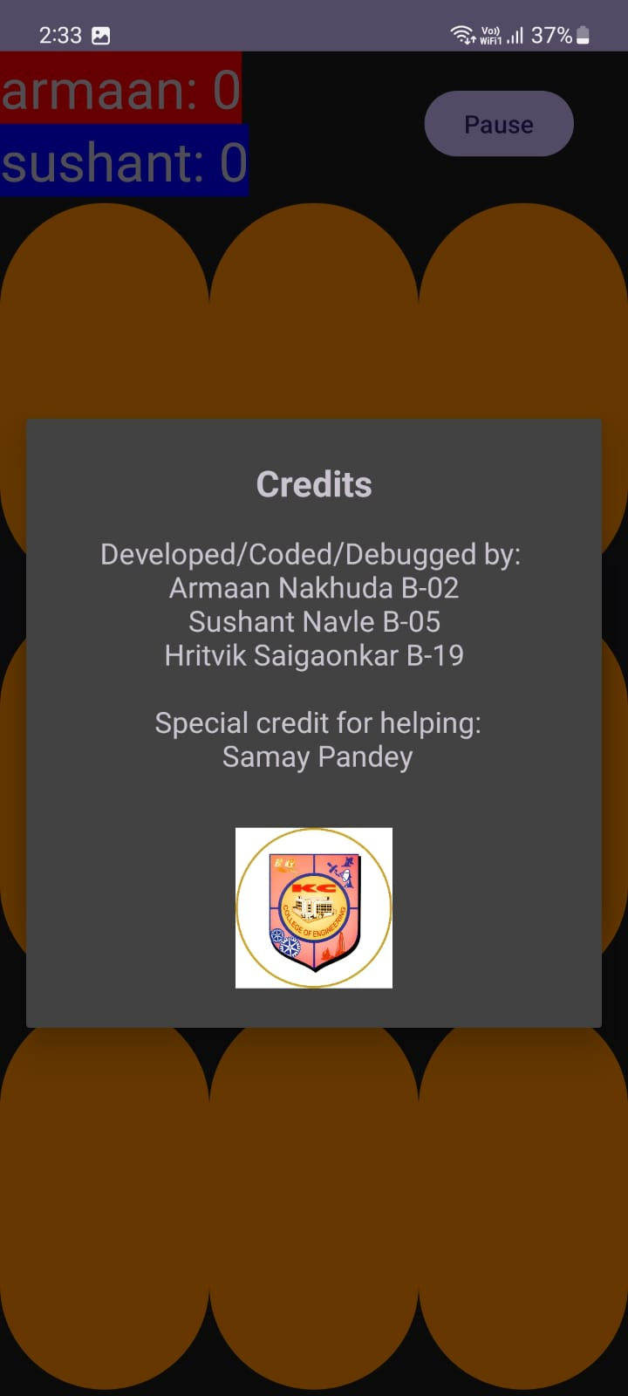

Figure 16 Figure 17

Figure 16 shows the pause menu that shows when the user clicks on the pause button, while Figure 17 shows the credits dialogue that can be accessed from the game startup screen and the pause menu.

22

3.5 Conclusion and Future Scope :-

Conclusion:-

In conclusion, HR MANAGEMENT SYSTEM is a classic and simple two-player game that has been enjoyed for generations. It offers a perfect balance of strategy and chance, making it an excellent choice for quick entertainment and brain stimulation. The game’s straightforward rules and limited possibilities make it easy for anyone to learn and play. It’s a game that transcends age and can be enjoyed by both children and adults, promoting critical thinking, spatial awareness, and strategic planning. Whether played on a sheet of paper, a digital platform, or a physical board, HR MANAGEMENT SYSTEM continues to be a timeless and enjoyable pastime for all.

Future Scope:-

1. The statement is talking about how the classic game of TICTACTOE Game, which is quite simple, can be made even more interesting and fun in the future by using new ideas and technologies.
2. Imagine you’re playing HR MANAGEMENT SYSTEM on your phone. Right now, you can play against a computer or a friend, and it’s a simple game. But in the future, there could be some cool changes:
3. The classic game of HR MANAGEMENT SYSTEM can be made more exciting in the future by using new technologies and ideas.
4. Potential improvements include smarter computer opponents, online play with people from around the world, and enhanced graphics and interactions.
5. The game could become more educational, offer various ways to customize the experience, and even support competitions and community-building.
6. Future enhancements aim to make HR MANAGEMENT SYSTEM more enjoyable, accessible, and engaging for players of all ages.

23

1. REFERENCE
2. LoadingActivity.java and activity_loading.xml: Loading screen when the user first opens the app.
3. GameoptionsActivity.java and activity_game_options.xml: The game options screen the user gets after the loading is complete, allowing the user to choose the options for the game.
4. MainActivity.java and activity_main.xml: The main user playable game after the game options menu.
5. Pause_menu.xml: An extra clickable and interactive dialog which has extra game options during a running game
6. Credits_dialog.xml: A secondary dialog which can be activated from the game starting screen or the pause menu.

24